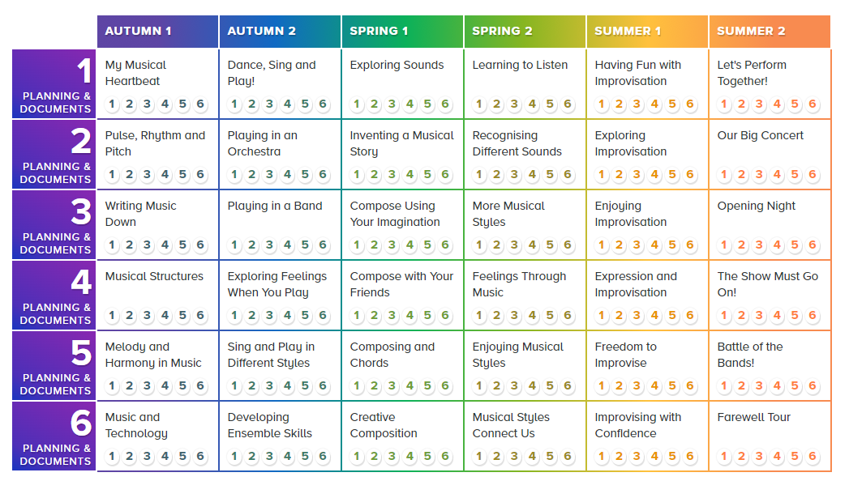

At New Delaval, we follow Charanga’s English Model Music Curriculum Scheme which aligned with the National Curriculum for Music and the non-statutory Model Music Curriculum (MMC) Guidance published by the DfE in 2021.