Nursery
Cycle A | Term 1 |  | Term 2 |  | Term 3
 | Autumn 1 | Autumn 2 | Spring 1 | Spring 2 | Summer 1 | Summer 2
Topic | Animals | Castles | Families | Traditional Tales | Growing | Holidays
Topic Intent | This topic will lead to learning about Autumn and different types of animals. | This topic will lead to learning about castles and the royal family. | This topic will lead to learning about the themselves and the local area. | This topic will lead to learning about traditional tales . | This topic will lead to learning about how things grow. | This topic will lead to learning about different cultures and countries.
Genre | Realistic Fiction | Fantasy | Cultural Fiction | Traditional Tales | Fiction | Realistic Fiction
Book Focus | Dear Zoo  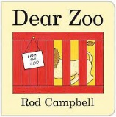 | Jack and the beanstalk  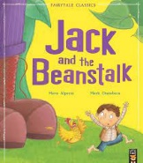 | So Much  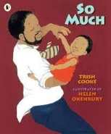 | The 3 Billy Goats Gruff  The 3 little pigs  Goldilocks and the 3 bears  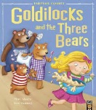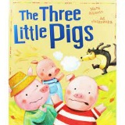  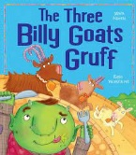 | The Hungry Caterpillar  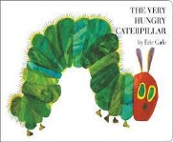 | The Train ride  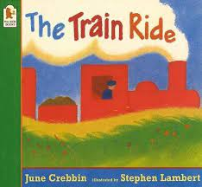
Book Focus Intent | This text will to the children gaining an understanding about Autumn. | These texts will lead to the children finding out about festivals. | These texts will lead to the children learning about people who help us and Chinese New year. | This text will lead to the children finding out about the religious festival of Easter. | This text will lead to the children finding about insects. | This text will lead to the children finding out about different sea creatures.
Themed weeks/ learning | Autumn  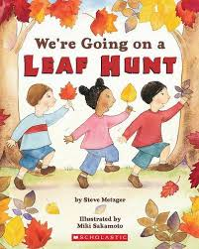 | Bonfire night  Christmas  Divali  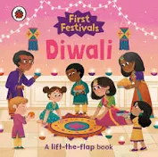 | Chinese New Year  People Who help us  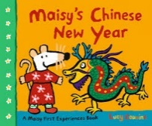 | Easter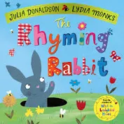 | Ladybirds and insects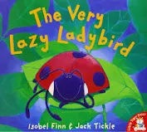 | Under the sea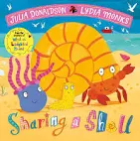

Communication and Language intention | I can listen to an adult when I am actively involved in an interactive adult-led activity, in a small group. I demonstrate my attention and recall by joining in with repeated refrains and by filling in gaps within familiar songs and rhymes. I can keep a steady beat by tapping my knees to music.  With familiar vocabulary, I can follow instructions containing three key words e.g. Put your shoes under the table. I select a familiar object based upon how it’s used when you ask e.g. give me the one you use to eat with/cut with/read etc.  I ask a variety of questions - what, who, where. I use plurals e.g. “I can see cats”. I talk about what I am doing and what I have done beyond the here-and-now. I add the consonants ‘k/c,’ ‘g,’ ‘f,’ ‘s’ and ‘y’ to my consonant range.  I use less familiar themes within my pretend play but still based upon my first hand experiences e.g. pretending to go to the doctor or pretending to be a waiter at a restaurant. I can pretend without an object e.g. pretending my hand is a cup and drinking from it. I can substitute objects that do not resemble the real thing e.g. pretending a block is a bus on its way to the bus station. | I listen in a small group with visual support. I follow body percussion sequences of three in the right order e.g. clap hands, tap knees, pat head.  I can follow instructions which includes holding a list of three items in mind before going to get them from another room e.g. can you get me a plate, a banana, and a knife from the kitchen please? I can answer simple ‘how’ and ‘why’ questions in relation to my experiences, that require no inference e.g. “why is Posy crying?”(adult) “She falled over” (child).  Unfamiliar adults are able to understand most of what I say. I use more complex sentence structure and link thoughts, ideas and events with ‘and’, ‘because’ and ‘so’. I use a range of word endings to describe the present tense e.g. -ing, -n’t. I add the consonants ‘z,’ ‘v,’ ‘sh,’ ‘ch,’ ‘j’ and ‘ng.’  I give my puppets, role play characters and small world characters a ‘voice’ so that they can ‘talk’ to each other. I play alongside other children who are engaged in the same pretend play theme as me, often in the same role. | I listen to others in one-to-one or small group situations even if the topic is not following my own interests. I am able to follow directions when I am not focused on another task.  I understand and follow instructions containing words related to time such as ‘before,’ ‘after,’ ‘first,’ ‘last’ and ‘later.’ I can answer simple problem solving questions, for example 'What do you do when you're hungry/cold?'  I use a variety of tenses, and understand grammatical rules but still sometimes make errors e.g. runned instead of ran. I use language to describe what I am going to do and how I am going to do it. I recount simple, past events in the right order e.g. “I goed to the shop with Granny and then we goed to the park.” I use most consonants consistently but ‘l,’ ‘r’ and ‘th’ may be still developing.  I can play imaginatively within themes I have not had first hand experience of but are often based upon favourite stories e.g. flying to the moon or being a pirate on a ship. I pretend with other children, each of us taking on different roles. I pretend using gestures, mime and unrealistic objects.

Personal, Social and Emotional Development intention | Teaching of RESPECT Curriculum – Resillience, Empathy, Self Awareness, Positivty, Excellence, Communication and Teamwork
 | 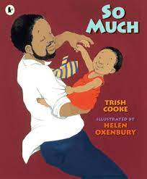  This text will lead to the children finding out about different cultures. | 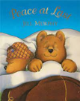  This text will encourage the children to hear different sounds around the home. | This text will lead to the children exploring different modes of transport, family and holidays.
 | I can wait my turn, when an adult is there to remind me, when I want to play on equipment e.g. going down the slide. I can choose what I want to do and find resources I need when playing.  I select activities and resources with help from an adult. I can eat using a spoon and fork. I can tell you when I need the toilet. I tell an adult when I am hungry or tired. I like to be praised by adults and taking responsibility for carrying out small tasks.  When it is on my own terms, I engage in simple pretend-play and talk to others as I play. I join in play with other children and initiate play with others. | I can take turns when I play simple games in a small group with an adult e.g. snap or a game of skittles. I can tolerate delay when my needs are not immediately met. I can tell you how I am feeling.  I can pull my pants down and up and go to the toilet myself. I can wash my own hands. I can drink from a cup (one handled), holding it in only one hand.  I actively seek out other children to play with and form friendships with other children. I keep play going by responding to what others say or do. | I enjoy the company of other children. I use words to negotiate rather than actions. I understand that my actions affect others. I am willing to participate in a wide range of activities. I usually adapt my behaviour to changes in routine or different social situations.  I am confident in asking adults for help. I am usually clean and dry during the day. I can wash and dry my own hands.  I understand how to take turns as well as how to share. I show care and concern for younger children and my friends if they are upset. I initiate conversations with others and take account of what they say.

Physical Development intention | 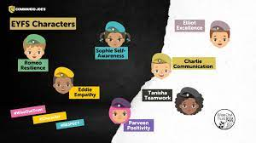
 | I hold a pencil between my first two fingers and thumb to copy a circle and a cross. I draw a person with a head and usually one or two other features e.g. eyes and mouth. I can roll dough into balls and sausage shapes. I can stack ten wooden blocks. I can snip with scissors.  I move freely in a range of ways, e.g. rolling, crawling, sliding, shuffling. I can run skill fully with wheeled toys, turning around obstacles and corners.  I recognise something when shown only a small part of the object e.g. What’s coming out of the box? When you show me half the object I can tell you what it is. I can find and point out to you specified features or items in books, pictures and my environment e.g. Can you find the tiny ladybird? | I can build three block ‘bridges’ to join my block towers together, when given a model to copy. I can draw a person with a head and legs. I can copy a ‘V’ shape. I cut with scissors. I can thread smaller beads and cotton reels onto a shoelace.  I can hop on one foot. I can jump over low level obstacles. I can walk up 10 steps, right, left, right, left, without holding rail.  I can match an item to its ‘shadow’ e.g. I place the spade back on the shelf on top of its corresponding ‘shadow’ at tidy-up time. I can identify a missing/hidden object when we play ‘hiding’ games involving up to 4 objects. I recognise and point out familiar logos/branding in my environment e.g. noticing the Asda sign in a new place. | I can build three steps with six cubes, when given a model a copy. I can draw a person with a head, body and legs and, usually, arms and fingers. I can draw a recognisable house. I cut along a straight line.  I can run smoothly with changes in speed, negotiating space successfully. I can jump off an object and land appropriately. I travel with increasing confidence and skill over, under, around and through equipment. I can climb low level ladders and trees using alternate hands and feet.

Literacy intention | 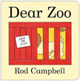 | 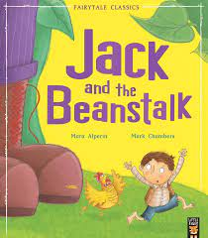 | 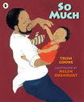 | 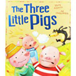 |  | 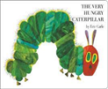 | 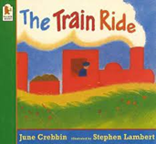
 | This text will encourage the children to name different animals. | This text will lead to the children being able to repeat repeated refrains. | This text will lead to the children finding out about different cultures. | This text will lead to the children being able to repeat repeated refrains. |  | This text will lead to the children finding out about the lifecycle of a butterfly. | This text will lead to the children exploring different modes of transport, family and holidays.
 | I recognise rhythm in spoken words and can blend compound words, e.g “snow-man”. I am aware that signs and symbols within the environment carry meaning. I fill in the missing words or phrases in known stories and rhymes.  I ascribe meaning to the marks I make when I draw or paint. I often provide a running commentary as I make marks. I do not distinguish between drawing and writing yet.  I can talk about key features of favourite stories I have heard by stating who was in the story (character) and where they were (setting). |  | I clap out one to three syllable words and blend two syllable words e.g. “ta-ble”. I spot when you make a ‘mistake’ during a rhyming activity and I tell you what the right word should be. I recognise my own name and know what sound it starts with.  I can copy the first letter of my own name. I can use magnetic or wooden letters to copy my name when you only give the letters I will need. I tell you what the things I have written ‘say’ and I now know that writing and drawing are different.  I demonstrate that I have listened and attended by answering simple questions about a story that has just been read to me e.g. “where did the rabbit go?” |  |  | I see the letters from my own name in other words. I orally blend three syllable words e.g. ‘e-le-phant.’ I look at books independently and know that print carries meaning. I can continue a rhyming string. I can hear and say the initial sound in words.  I can copy most letters from my name. I use some clearly recognisable letters in my own writing. I use writing in my play e.g. to write a shopping list during role-play. I can tell you what I am going to draw and write before I create my special marks.  I actively listen to stories and can retell familiar stories. I listen to stories from beginning to end and can answer questions based on the story.
Mathematics intention | 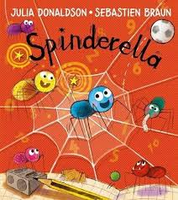  This text will encourage the children to repeat numbers in order. |  | This text will encourage the children to count and say correct number. |  |  | 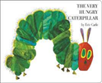  This text will lead to the children counting the food in the story.
 | I can recite number names with the intention of counting but they aren’t always in the correct order. I understand the concept of first and second by telling you who the winner is after racing cars etc.  I can give out objects to other children for the purposes of sharing although not equally e.g. if I have a box of cars I may give 1 to a friend then keep the rest. |  | verbally count to ten with some correspondence with objects - I may point to objects to count a few items but often lose track. I can compare sets of 1-4 items by subitising (recognising by sight) when the items in each set are the same or similar in size and type e.g. compare 3 bears and 2 bears.  I can add or subtract very small collections non-verbally e.g. when shown 2 objects then another under a napkin, I make a set of 3 to ‘match’. |  |  | I can count (up to 5) accurately using 1:1 correspondence when the objects are similar and placed in a line. I often recount the objects when you ask me how many altogether. I can match small, same size sets of dissimilar items such as comparing 4 bears and 4 chairs and show that they are the same amount. I can non-verbally make a small collection (no more than 5), with the same number as another collection, e.g. when shown a collection of 3 I make another collection of 3. I recognise numerals of personal significance.  I know that different things can be counted, e.g. steps, jumps, hops. I can share up to 4 objects between 2 people by dealing out 1 for 1 e.g. to share 4 blocks, the child gives each child a block, checks each has 1 then repeats.
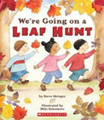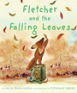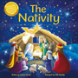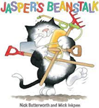
These texts will lead to the children finding out about seasons, the natural world and celebrations.
Understanding the World intention
 | Are able to say who they are and who they live with.  Use all their senses in hands on exploration of natural materials.  Can talk about pets they might have.  Explore how things work.  Can talk about family members. |  | Begin to make sense of their own life story and family’s history.  Sequence family members by size.  Shows interest in different occupations.  Plant seeds and care for growing plants.  Comments on fictional characters from stories.  Understand the key features of the life cycle of a plant and an animal. |  |  | Sequence family members explaining who they are (adult, baby)  Talks about a wider range of occupations.  Begins to understand the need to respect and care for the natural environment and all living things.  Know that there are different countries in the world and talk about the differences they have experienced or seen in photos.  Continue developing positive attitudes about the difference between people.
Expressive Arts and Design intention | 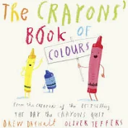 | 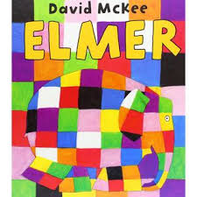 | 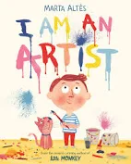 |  | 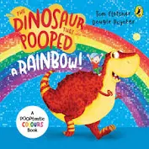 | 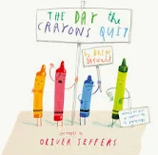 |  | 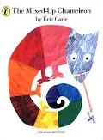
 | Explore different materials, using their senses to investigate them.  Manipulate and play with different materials.  Use their imagination as they consider what they can do with different materials.  Make simple models which express their ideas.  Start to develop pretend play, pretending that one object represents another.  Use Premade paints.  Name colours.  Can hold a paint brush.  Begin to develop complex stories using small world equipment like animal sets and dolls. |  | Explore mixing colours.  Print with blocks and sponges.  Explore different materials freely, in order to develop their ideas.  Respond to what they have heard, expressing their thoughts and feelings.  Remember and sing entire songs. |  |  | Talk about what happens when primary colours are mixed.  Join different materials and explore different textures.  Sing the pitch of a tone sung by another person.  Draw faces with features and lots of detail.  Draw things they observe with detail.  Draw with increasing complexity and detail, such as representing a face as a circle.  Show different emotions in their drawings and paintings.  Create their own songs around one they know.
Class library will have fiction and non-fiction books added termly to reflect the topic/book/genre including blue topic boxes

