Preschool
Cycle A | Term 1 |  | Term 2 |  | Term 3
 | Autumn 1 | Autumn 2 | Spring 1 | Spring 2 | Summer 1 | Summer 2
Topic | My Family/ All about me/ people who are special to me | That’s Not My.../  Dear Zoo | Pip and Posy/  Transport | Growing/  Farm animals | The Hungry Caterpillar/ numbers/colours | The sea/ In the Jungle
Topic Intent | This topic will lead to learning about my family and Nursery Rhymes | This topic will lead to learning about animals and sounds | This topic will lead to learning about different modes of transport | This topic will lead to learning about Growing, planting, and animals that live on the farm | This topic will lead to learning about caterpillar’s, colours, counting to 5 different foods | This topic will lead to learning about Sea creatures/ Jungle animals
Genre | Realistic | Realistic | Realistic | Realistic | Realistic | Realistic
Book Focus | 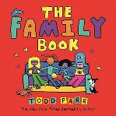  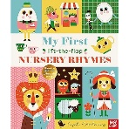 | 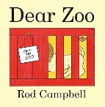  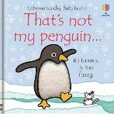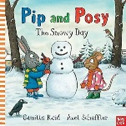 | 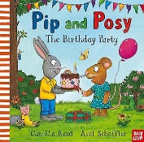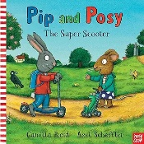 | 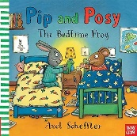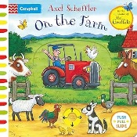 | 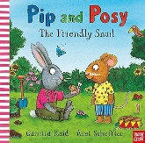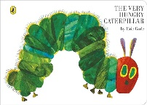 | 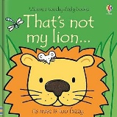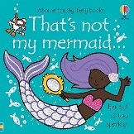
Book Focus Intent | These texts will lead to learning about my family and will introduce the 10 core rhymes. | These texts will lead to learning about animals, sounds, winter, and celebrations. | These texts will Introduce Pip and Posy and learn about our RESPECT characteristics. | These texts will lead to learning about farm animals, plants and spring. | These texts will lead to learning about Numbers, colours, and foods. | These texts will lead to learning about jungle animals, sea creatures.
These texts (with the black border) are our preschool core books.
Themed weeks/ learning | Halloween | Bonfire night  Christmas  Remembrance Day  Children in need  Christmas jumper day | Pancake day  Chinese New Year | Mother's Day  Easter  World book day | St Georges Day | Father's Day  Sports day  Transitions

Communication and Language intention | 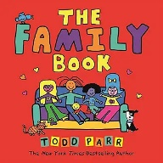  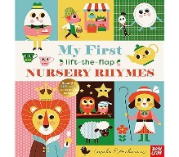 | 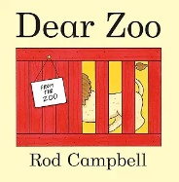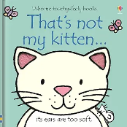 | 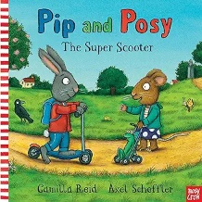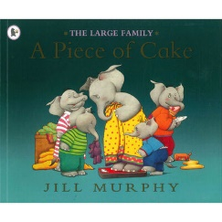 | 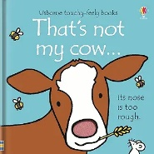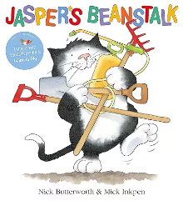 | 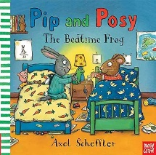  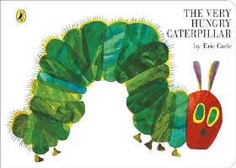 | 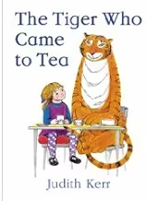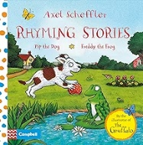
 | Enjoy sharing books with an adult.  Enjoy songs and rhymes, tuning in and paying attention.  Pay attention and respond to the pictures or the words. | When you use familiar vocabulary, I can follow instructions with two  key words.  I use simple sentences containing three words.  I discriminate a sound in my environment and name it e.g. dog barking, doorbell. | Have favourite books and seek them out, to share with an adult, with another child, or to look at alone. | Develop play around favourite stories using props. | Repeat words and phrases from familiar stories. Ask questions about the book.  I ask a variety of questions - what, who, where.  Sing songs and say rhymes independently, for example, singing whilst playing. | I demonstrate my attention and recall by joining in with repeated refrains and by filling in gaps within  familiar songs and rhymes.

Personal, Social and Emotional Development intention | 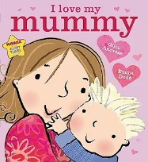  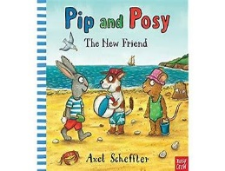 | 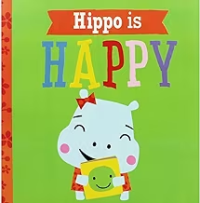 | 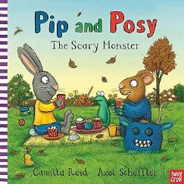  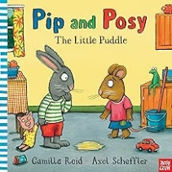 | 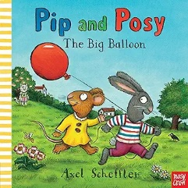 | 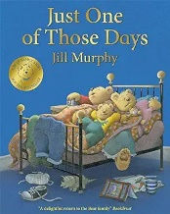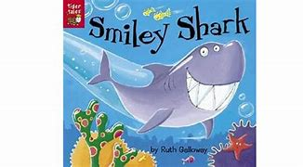 | 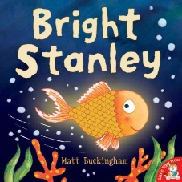
 | I play happily near other children but not usually with them. I use an adult as a secure base from  which I explore new environments.  I am affectionate with adults who are  special to me. | I watch other children play with interest, occasionally joining in for a few minutes.  I can take my own shoes, socks and shorts or pants off. I can feed myself competently with a spoon. | I am reassured by a familiar adult when I am tired or frightened.  I am aware of when my pants are wet and know what a toilet/potty is used for. I can recognize myself  when I look in the mirror. | I can combine pretend actions together related to a familiar routine e.g. I get a bowl and spoon,  pretend to pour cereal and serve it to a doll.  I use less realistic objects when they are similar in shape to the real object e.g. using a ball as an apple to feed the doll.  I take part in an adult-directed task for a short period one-to-one even if this is not a favoured activity. | I show affection  towards people who are special to me.  When it is on my own terms, I engage in simple pretend-play and talk to others as I play. | I can choose what I want to do and find resources I need when playing.  I join in play  with other children and initiate play with others.

Physical development | 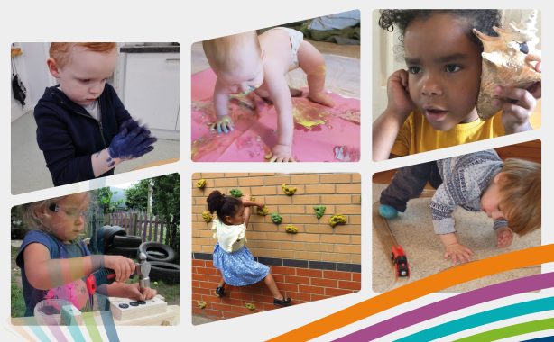
 | I can push and pull large, wheeled toys easily forwards and usually I am able to walk backwards pulling a handle.  I can climb up onto adult-sized furniture. | I make vertical, horizontal and circular marks.  I can stack seven wooden blocks.  I can pour from one container to another.  I create marks with a paintbrush by bending my wrist using a dabbing motion. | I can run avoiding obstacles.  I can climb simple climbing equipment e.g. climbing up and over.  I can jump off a low step with two feet together.  I can kick a ball gently without falling over. | I can match an item to a photograph of the same item e.g. putting a book back on the shelf when matched to a photograph of its front cover.  I point out tiny features in books and pictures to you. | I hold mark-making tools to spontaneously ‘scribble’ and can imitate drawing vertical lines.  I can turn the pages of a book one at a time.  I can stack five wooden blocks.  I can thread large cotton reels or big beads onto a dowling | I match two of the same objects even if they are different sizes or colours.  I recognise favourite people in photographs.

Literacy intention | 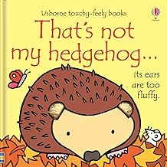  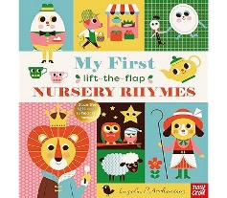 | 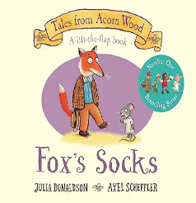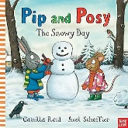 | 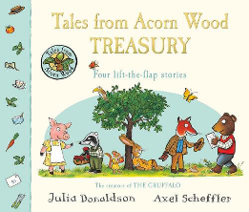 | 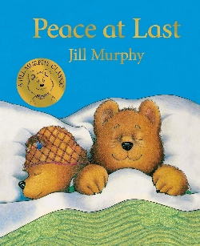 | 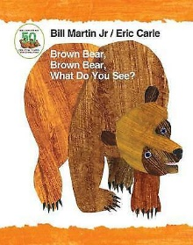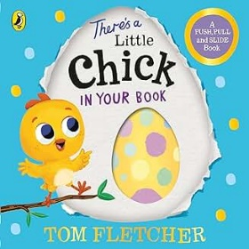 | 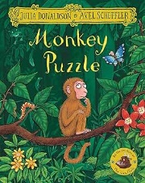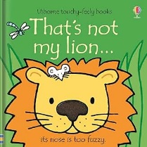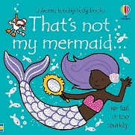
 | Enjoy songs and rhymes, tuning in and paying attention.  Enjoy sharing books with an adult. | Join in with songs and rhymes, copying sounds, rhythms, tunes and tempo.  Pay attention and responds to the pictures or the words. | Have favourite books and seeks them out, to share with an adult, with another child, or to look at alone  Notice some print, such as the first letter of their name, a bus or door number, or a familiar logo. | Copy finger movements and other gestures.  Have favourite books and seeks them out, to share with an adult, with another child, or to look at alone | Repeat words and phrases from familiar stories. Ask questions about the book. Makes comments and shares their own ideas. | I can talk about key features of favourite stories I have heard by stating who was in the story  (character) and where they were (setting).
 | These texts will provide a hook into learning about Autumn | These texts will provide a hook into learning about Winter and animals | These texts will provide a hook into learning about being kind and sharing | This text will provide a hook into learning about being kind and sharing | These texts will provide a hook into learning about spring and animals | These texts will provide a hook into learning about the sea and jungle animals

Mathematics intention | 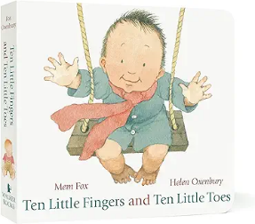  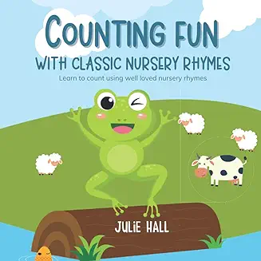 | 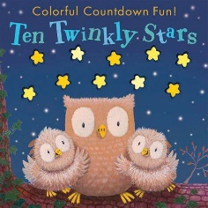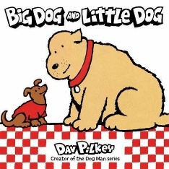 | 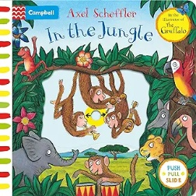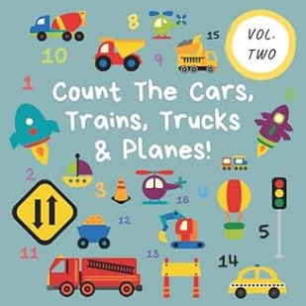 | 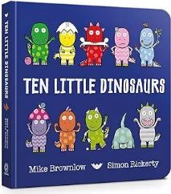  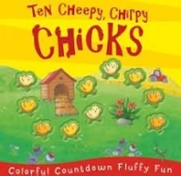 |  | 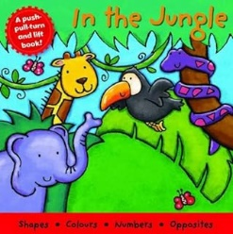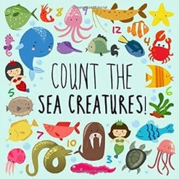
 | Take part in finger rhymes with numbers. | Take part in finger rhymes with numbers.  Counting-like behaviour, such as making sounds, pointing or saying some numbers in sequence. | Counting-like behaviour, such as making sounds, pointing or saying some numbers in sequence. | Count in everyday contexts, sometimes skipping numbers - ‘1-2-3-5.’ | Notice patterns and arrange things in patterns. | I can give out objects to other children for the purposes of sharing although not equally
Understanding the World intention | 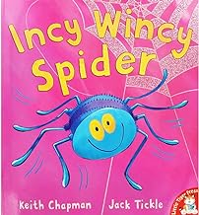 | 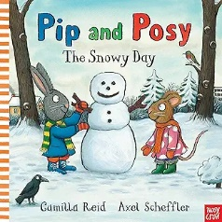  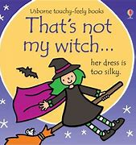 | 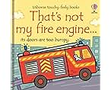  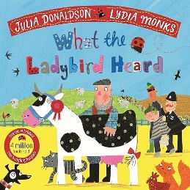 | 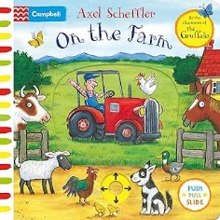 | 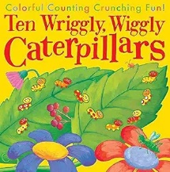 | 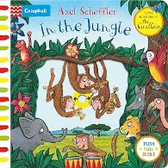
 | Make connections between the features of their family and other families.  Repeat actions that have an effect.  Explore materials with different properties linked to autumn. | Make connections between the features of their family and other families.  Explore materials with different properties linked to winter. | Repeat actions that have an effect. | Explore natural materials, indoors and outside.  Explore and respond to different natural phenomena linked to spring. | Explore natural materials, indoors and outside. | Use all their senses in hands-on exploration of natural materials
Expressive Arts and Design intention | 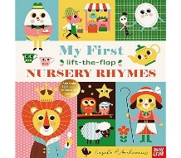 | 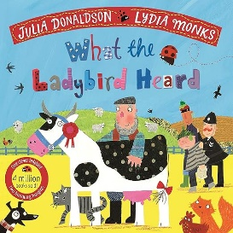 | 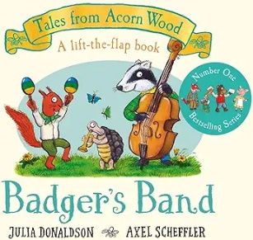 |  |  | 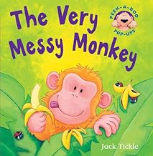
 | Enjoys using hands/feet and fingers to paint  Join in with songs and rhymes, making some sounds. | Make rhythmical and repetitive sounds. | Start to make marks intentionally.  Explore a range of sound-makers and instruments and play them in different ways. | Express ideas and feelings through making marks, and sometimes give a meaning to the marks they make.  Sing songs, such as ‘Twinkle, Twinkle Little Star’. | Explore different materials, using all their senses to investigate them. Manipulate and play with different materials.  Use their imagination as they consider what they can do with different materials.  Make simple models which express their ideas. | Start to develop pretend play, pretending that one object represents another. For example, a child holds a wooden block to her ear and pretends it’s a phone

