Reception
Cycle A | Term 1 |  | Term 2 |  | Term 3
 | Autumn 1 | Autumn 2 | Spring 1 | Spring 2 | Summer 1 | Summer 2
Topic | Getting to know you, getting to know all about you! | Toys | Our dreams and wishes | We love to tell stories! | Where should we visit next? | Castles, knights and dragons
Topic Intent | This topic will lead to learning about the themselves and the local area. | This topic will lead to learning about past and present. | This topic will lead to learning about jobs in our community. | This topic will lead to learning about traditional tales and how to write a good story. | This topic will lead to learning about different cultures and countries. | This topic will lead to learning about castles and the royal family.
Genre | Traditional Literature/ Poems | Historical Fiction | Realistic Fiction | Traditional Tales | Cultural Fiction | Fantasy
Book Focus | 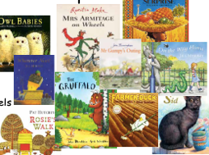  Nursery Rhymes  Core Books | 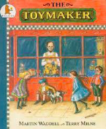  The Toy Maker by Martin Wadell | 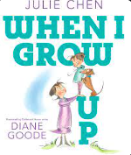  When I Grow up by Julie Chen | 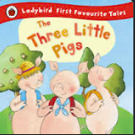  3 little pigs by various authors | 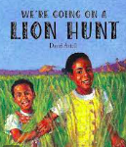  We’re going on a lion hunt by David Axtell | 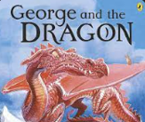  George and the Dragon by Chris Wormell
Book Focus Intent | These texts will lead to children developing a love for reading. They will devlop their Language, Comprehension, Characters, Authors and Illistraters. They will become so familiar with the texts that children will be able to recall them within their play and through helicipter stories.  Foundational knowledge for KS1 where am I in the world topic. Science – animals including humans. | This text will lead to understanding the vocabulary ‘past’ and ‘present’. They will be able to talk about similarities and differences from the past and present.  Foundational knowledge for KS1 transport in the past. | This text will lead to children developing an understanding of how they have changed from babies to now. They will also learn about different job opportunities and their role within the community.  Foundational knowledge for KS1 great fire/ grace darling.  Foundational knowledge for KS1 PSHE living in the wider wolrd – what job could I have? | This text will lead to children being able to retell their own story using a story map, story mountain or the story stage. Children will learn about what makes a good traditional tale.  Foundational knowledge for KS1 little red hen/ little red riding hood. Science – everyday materials. | This text will lead to a greater understanding into how the lives of people in other countries may be different to theirs.  Foundational knowledge for KS1 going on safari. | This text will lead into the discussion of castles, developing vocabulary and learning about why castles were built. This text will lead into the discussion of our Royal Family.  Foundational knowledge for KS1 castles/ royal family topic.
Themed weeks/ learning | - Our Community - Map work  - Autumn | - Christmas  - Our families / our celebrations  - Toys then and now  - Winter – glaciologists  - Church visit | - People who help us  - Artist – Claude Monett  - ‘Little people big dreams’ books  - Us then and now | - Caterpillars  - Life cycles  - Spring  - Church visit – Easter | - Growing and planting | - Summer

Communication and Language intention | 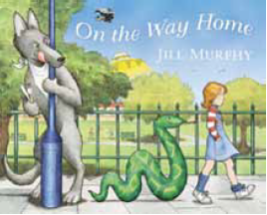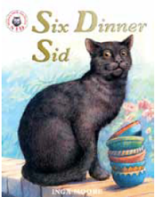  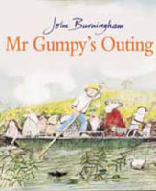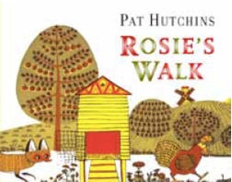  Core book focus | 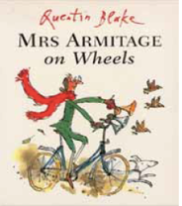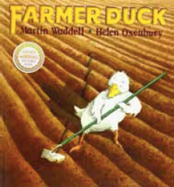  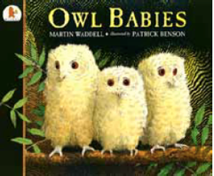  Core book focus | 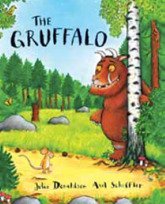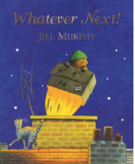  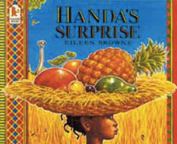  Core book focus
 | To listen to others in one-to-one or small group.  To follow directions when I am not focused on another task.  To follow instructions containing words related to time.  To answer simple problem solving questions.  To use a variety of tenses, and understand grammatical rules but still sometimes make errors  To use language to describe what I am going to do and how I am going to do it.  To recount simple, past events in the right order.  To play imaginatively within themes I have not had first hand experience of but are often based upon favourite stories.  To pretend with other children. | To listen in larger groups when distractions are minimised.  To listen to instructions without having to stop what I am doing.  To understand and follow more complicated instructions.  To offer reasons and explanations when answering ‘how’ and ‘why’ questions.  To link sentences and generally stick to the topic of conversation.  To give a more detailed account of recent events and experiences  To clarify my ideas by thinking out loud e.g. talking with a friend  To repeat back new vocabulary correctly.  To use gestures and expression within my voice to bring my imaginary characters to life. | To listen and attend well in a classroom environment even with distractions. To understand time and sequence concepts and use terms such as first, then, last.  To constantly ask the meaning of abstract words. To usually understand jokes and riddles and have a definite sense of humour.  To understand and use positional language. To understand and use a range of adjectives to describe objects and situations.  To speak confidently to peers and adults taking part in longer conversations, staying on topic, showing an awareness of who is listening, expressing and listening to views and opinions.  To talk about things that have happened accurately as well as things that are to happen in the future in great detail.  To act out in detail stories I have been read or told To make up new stories with others which are increasingly detailed in their structure.

Personal, Social and Emotional Development intention | Teaching of RESPECT Curriculum – Resillience, Empathy, Self Awareness, Positivty, Excellence, Communication and Teamwork
 | 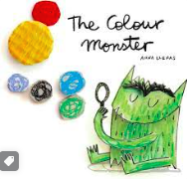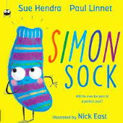  The Colour monster  Simon Sock | 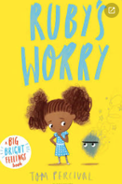  Rubys Worry | 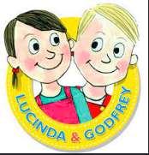  Lucinda and Godfrey Foundation Stage
 | To enjoy the company of other children.  To use words to negotiate rather than actions.  To understand that my actions affect others.  To participate in a wide range of activities.  To confidently ask adults for help.  To take turns and share.  To name the different feelings.  To be able to say how I am feeling.  To be able to notice if someone is feeling a certain way.  Foundational knowledge for KS1 what rules do we have? | To take pleasure in winning games.  To regulate my feelings by drawing on a range of strategies I know.  To choose the necessary equipment I need to complete a task.  To undress and dress myself independently,  To eat using a fork and knife.  To show sympathy towards other children who are in distress.  To initiate conversations with familiar adults and children.  To discuss how it feels when I am worried about something.  Foundational knowledge for KS1 relationships -n who can help u s? | To generally be sensible, controlled and independent in my behaviour  To follow tidy up routines and have a strong sense of time in relation to the daily routine.  To describe what I am going to do before I do it  To fold my clothes.  To work out how people feel, what has happened or what is wrong when 'reading' non-verbal communication or when looking at non- verbal and situational clues in pictures.  To play cooperatively most of the time, establishing and sticking to agreed rules for fair play.  To be gentle and protective towards younger children and enjoy showing them how things are done.  To appreciate the similarities and differences between boys and girls including the correct names of body parts.  Foundational knowledge for KS1 how do we feel Lucinda and Godfrey.

Physical Development intention | 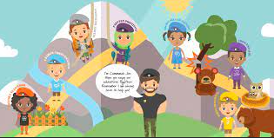  Commando Joe’s Characteristics
 | Fundamental movements  NUF – Commando Joe’s | Commando Joe’s  NUF – Problem and Challenge |  | Balance  NUF – Multi Skills | Cricket – Northumberland Cricket  NUF – Attack and Defence | Comando Joe’s  NUF – Striking &Fielding / Net and ball |  | Sports Day Activities  NUF – Athletics & Fitness
 | To build three steps with six cubes, when given a model a copy.  To draw a person with a head, body and legs and, usually, arms and fingers.  To draw a recognisable house.  To cut along a straight line.  To run smoothly with changes in speed, negotiating space successfully.  To jump off an object and land appropriately.  To travel with increasing confidence and skill over, under, around and through equipment. |  | To hold a pencil in a dynamic tripod grasp with good control.  To cut out shapes with curved lines.  To use range of everyday tools effectively.  To navigate movement from one place to another skillfully, turning sharp corners, running, pushing and pulling themselves.  To skip using alternate feet rather than galloping.  To bounce and throw a large ball, catch it using my arms and body and strike it using my foot or a bat. |  |  |  | To thread large needles and sew big stitches.  To build elaborate models.  To coordinate my shoulder, wrist and finger movements to write comfortably, moving across and down the page, holding the paper in place to correctly form most letters.  To produce more detailed drawings containing several objects and usually an indication of the background environment  To jump forward a number of times without falling.  To throw and catch a ball well with two hands.  To can walk easily along a narrow line or on a balance beam.  To hop on one leg over longer distances.
 | Foundational Knowledge for English – handwriting.

Literacy intention | 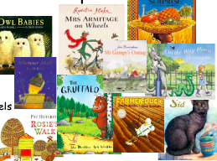  Nursery Rhymes  Core Books | The Toy Maker by Martin Wadell | When I Grow up by Julie Chen | 3 little pigs by various authors |  | We’re going on a lion hunt by David Axtell | 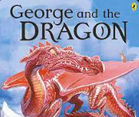  George and the Dragon by Chris Wadell
 | These texts will lead to children developing a love for reading. They will develop their Language, Comprehension, Characters, Authors and Illistraters. They will become so familiar with the texts that children will be able to recall them within their play and through helicipter stories.  There will be a focus on developing imaginative langauge through prediction and thinking of new ideas. | This text will lead to understanding the vocabulary ‘past’ and ‘present’. They will be able to talk about similarities and differences from the past and present.  There will be a focus on who the main characters are in the story and retelling the story through a story map. | This text will lead to children developing an understanding of how they have changed from babies to now. They will also learn about different job opportunities and their role within the community.  There will be a focus on writing for a variety of different purposes | This text will lead to children being able to retell their own story using a story map, story mountain or the story stage. Children will learn about what makes a good traditional tale.  There will be a focus on learning and recite this story using Talk4Writing actions. |  | This text will lead to a greater understanding into how the lives of people in other countries may be different to theirs.  There will be a focus on  innovating by adapting the characters/ problem on the story map. | This text will lead into the discussion of castles, developing vocabulary and learning about why castles were built. This text will lead into the discussion of our Royal Family.  There will be a focus on  innovating by adapting the characters/ problem on the story map and writing for a variety of different purposes.
 | To actively listen to stories and can retell familiar stories.  To listen to stories from beginning to end and can answer questions based on the story. |  | To use vocabulary and forms of speech that are increasingly influenced by my experiences of books.  To answer questions related characters or events within a familiar story. |  |  | To orally retell a simple 5 part story.  To recall familiar stories by creating various representations of them e.g. story maps, role-play.  To make up new stories that are often based on familiar tales.  To have a clear understanding of the beginning, middle and end of stories.  To follow a story without pictures or props.
 | Foundational Knowledge for English – word reading, comprehension, writing, composition, vocabulary, punctuation and grammar.
Mathematics intention | 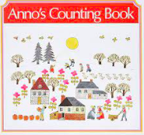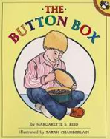  Annos counting  Button box |  | 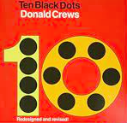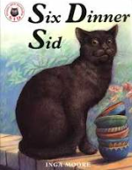  Ten black dots  Six dinner sid |  |  | 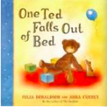  One ted falls out of bed
 | To count (up to 5) accurately using 1:1 correspondence when the objects are similar and placed in a line.  To often recount the objects when you ask me how many altogether.  To match small, same size sets of dissimilar items such as comparing 4 bears and 4 chairs and show that they are the same amount.  To nonverbally make a small collection (no more than 5), with the same number as another collection.  To recognise numerals of personal significance.  To know that different things can be counted, e.g. steps, jumps, hops.  To share up to 4 objects between 2 people by dealing out 1 for 1. |  | To accurately count a given set of objects to 5 placed in a random order and answer “how many?” with the last number counted without having to recount the objects.  To compare same and different sized sets of up to 6 objects by matching and can tell if the answer is the same.  To instantly recognise collections up to 4 when briefly shown and verbally name the number of items.  To solve simple number problems by adding two numbers together (with a total of no more than 5)  To share up to 6 objects between 2 or more people. |  |  | To count structured arrangements of objects to 10 including accurately making a set of objects up to 5 when counting out from a larger set.  To find the number just after or just before a given number but only by starting the count from 1 every time.  To identify and use ordinal numbers from first to tenth  To verbally label all arrangements to 5 when shown only briefly.  To solve simple word problems using a part-part-whole method.  To use my subitising skills to work out the total without using physical counting aids. (within 5)  To solve simple word problems relating to subtraction using physical counting aids to remove quantities and find the total.
 | Foundational Knowledge for Maths – number and place value, addition and subtraction, multiplication and division, fractions, measurement, geometry – properties of shape an position and direction.
Understanding the World intention | 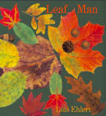  Leaf man by Lois Ehlert | 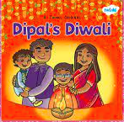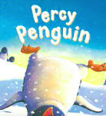Dipal’s Diwali  Percy Penguin | 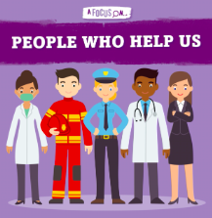  People who help us texts |  | 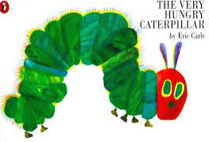  The Very Hungry Caterpillar | 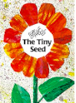  The Tiny Seed |  | 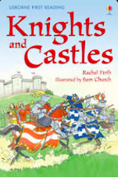  Knights and Castles texts
 | This text will provide a hook into developing vocabulary and knowledge surrounding the four seasons and weather patterns.  to know all about you’ topic will provide the opportunities for children to talk about members of my immediate family and community.  To discuss different occupations during play.  To explore their natural world.  Foundational knowledge for KS1 caring for out environment topic. Geography – place knowledge – Blyth  Foundational knowledge for KS1 where am I in the world topic. Geography – locational knowledge  Foundational knowledge for KS1 uk weather and seasons topic. Science – seasonal changes | Dipal’s Diwali  This text will provide a hook into learning about different cultures, such as Hinduism.  Percy Penguin  This text will provide a hook into learning about winter and Glaciologists.  ‘toys’ topic will lead to understanding the vocabulary ‘past’ and ‘present’. They will be able to talk about similarities and differences from the past and present.  Foundational knowledge for KS1 habitats knowledge/ super scientists. Science – seasonal changes  Foundational knowledge for KS1 who would live in a cold place?  Geography – locational knowledge – human and physical (seasons and weather) | This text will provide opportunities to I compare and contrast characters from stories, inc. figures from the past. It will provide a hook into learning about jobs in our community and what job we might want when we grow up.  ‘Our Dreams and wishes’ topic will lead to children developing an understanding of how they have changed from babies to now. They will also learn about different job opportunities and their role within the community.  Foundational knowledge for KS1 explorers.  History – lives of significant individuals  History – changes in living memory |  | This text will provide a hook into learning about the four seasons and weather patterns alongside life cycles.  ‘3 little pigs by various authors’ topic will lead children to experiment with different materials, name them, describe them and assemble with them.  Foundational knowledge for KS1 everyday materials topic.  Foundational knowledge for KS1 habitats knowledge. | This text will provide a hook into observing how seeds develop over time.  ‘Where should we visit next?’ Topic will provide opportunities to identify similarities and differences between life in this country and life in other countries.  To recognise that some environments are different to the one that I live in  To understand the effect of changing seasons on the natural world around them.  Foundational knowledge for KS1 growth and survival topic.  Foundational knowledge for KS1 climate continents and oceans.  Foundational knowledge for KS1 going on safari.  Science – seasonal changes |  | This text will lead into the discussion of castles, developing vocabulary and learning about why castles were built.  This text will lead into the discussion of our King and the Royal Family, focusing on developing relevant vocabulary  Foundational knowledge for KS1 castles/ royal family topic.  History – lives of significant individuals
 | Project Evolve – Self image and identity | Project Evolve – Online Relationships | Project Evolve – Online Bullying |  | Project Evolve – Wellbeing and lifestyle | Project Evolve – managing online information |  | Project Evolve – Online Reputation
Expressive Arts and Design intention | Combine harvesters – junk modelling  Gisepe archimboldo | Sock puppets | Engineers – building a ___ for the ____ ( people who help us) – junk modelling  Elephant island  Claude monet  Foundational knowledge for KS1 inventors topic. |  | Building houses out of different materials. | Junk modelling safari animals + paper mâché |  | Dragon / castle junk modelling
 | To explore, use and refine a variety of artistic effects to express my ideas.  To return to and build on my previous learning, refining ideas and developing my ability to represent them.  To create collaboratively, sharing ideas, resources and skills.  To create my own songs, or improvise a song around one I know. |  | To add black or white to alter tint and use colour for a purpose.  To draw people with bodies using lots of detail  To watch and talk about dance and performance art, expressing my feelings and responses.  To sing in a group or on my own, increasingly matching the pitch and following the melody. |  |  | To join assemble, modify their creations  To explore and engage in music making and dance, performing solo or in groups.
Foundational Knowledge for Art – using materials, drawing, making sculptures, studying a range of artists.
Foundational Knowledge for Music – using voices for songs, play tuned and untuned instruments, listening and concentrating.
Class library will have fiction and non-fiction books added termly to reflect the topic/book/genre including blue topic boxes

