Dear Parent/Carer
Breakfast Club

I am pleased to advise that we will be operating our Breakfast Club again this academic year, which is open to pupils in Reception to Year 6, commencing Monday 11th of September 2023.

The club will operate between 7.30am and 8.30am with the latest drop off time being 8.15am.

Children will be able to choose from a variety of cereals, yoghurts, fresh fruit, toast and crumpets/pastries, with a choice of fruit juice.

The cost for all children (including those entitled to Free School Meals) is £2.50 per day, this can be paid daily or in advance. Please note sessions need to be paid for even if your child does not attend unless it is due to sickness/medical appointment which has been notified to the school office.

Places will be allocated on a ‘first come first served’ basis, please note if your child previously attended breakfast club you must complete the form below, places will not automatically be carried forward.

If you would like a place for your child please complete and return the form below.

Yours sincerely,
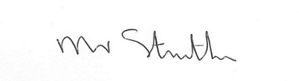
Mr P Struthers
Headteacher
------------------------------------------------------------------------------------------------------------------------
Breakfast Club

Pupil Name ……………………………………………………. Class…………………………..

I would like a place at Breakfast Club for my child on the following days:

Monday | Tuesday | Wednesday | Thursday | Friday

Signed …………………………………………………… Parent/Carer

